Лабораторная работа № 4.
Использование контейнеров.
Выполнял Шеменев В.В. ИСП-3-27

import 'package:flutter/material.dart';

void main() => runApp(MaterialApp(
home: Scaffold(
body: Column(
children: [
const Row(
children: [
Expanded(child: Text('Главная', textAlign: TextAlign.center)),
Expanded(child: Text('Стихи', textAlign: TextAlign.center)),
Expanded(child: Text('Инфо', textAlign: TextAlign.center)),
],
),
const Expanded(
child: Center(child: Text('У лукоморья дуб зелёный;\nЗлатая цепь на дубе том:\nИ днём и ночью кот учёный\nВсё ходит по цепи кругом;\nИдёт направо — песнь заводит\nНалево — сказку говорит.', textAlign: TextAlign.center)),
),
Container(
color: Colors.green,
child: const Row(
children: [
Expanded(child: Text('Шеменев В.В. ИСП-3-27', style: TextStyle(fontWeight: FontWeight.bold))),
Expanded(child: Text('А.С. Пушкин', textAlign: TextAlign.right)),
],
),
),
],
),
),
));
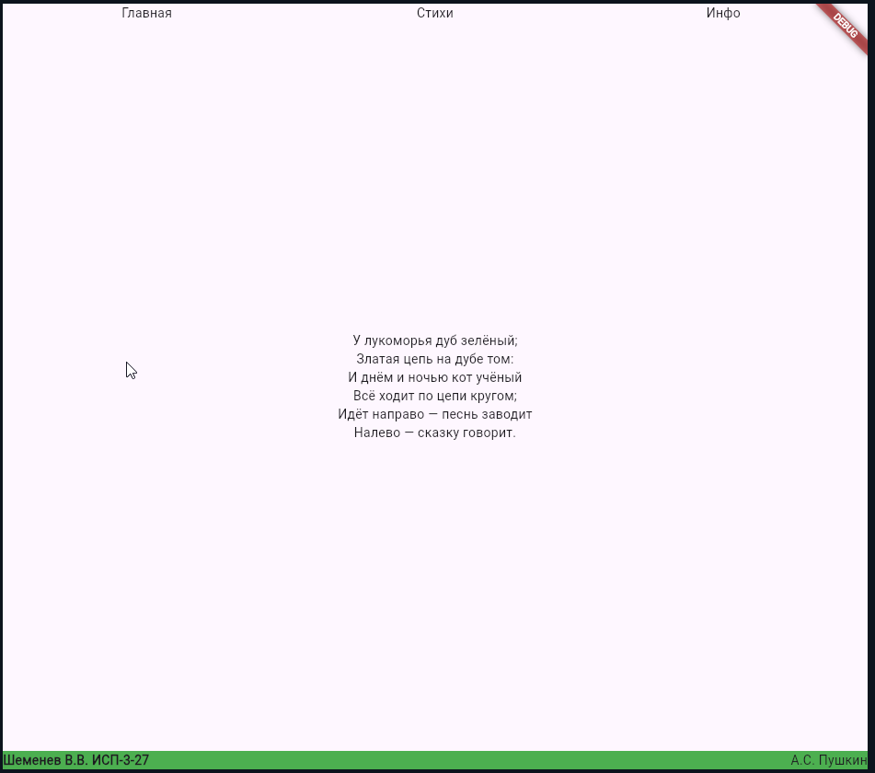

import 'package:flutter/material.dart';

void main() {
runApp(
Container(
color: Colors.white,
padding: EdgeInsets.all(10),
child: Column(
textDirection: TextDirection.ltr,
children: [
Container(
height: 60,
alignment: Alignment.topCenter,
decoration: BoxDecoration(
color: Colors.grey[400],
border: Border.all(color: Colors.brown, width: 3),
),
child: Text('Я УЖЕ СЕРЫЙ', textDirection: TextDirection.ltr),
),
SizedBox(height: 15),
Row(
textDirection: TextDirection.ltr,
children: [
Expanded(
child: Container(
height: 120,
margin: EdgeInsets.all(2),
alignment: Alignment.centerLeft,
decoration: BoxDecoration(
color: Colors.red,
border: Border.all(color: Colors.blue, width: 4),
borderRadius: BorderRadius.circular(15),
),
child: Padding(
padding: const EdgeInsets.only(left: 8.0),
child: Text('Я КРАСНЫЙ', textDirection: TextDirection.ltr),
),
),
),
Expanded(
child: Container(
height: 120,
margin: EdgeInsets.all(2),
decoration: BoxDecoration(
color: Colors.orange[200],
border: Border.all(color: Colors.blue, width: 4),
borderRadius: BorderRadius.circular(15),
),
child: Center(child: Text('КУЛЬТУРНО НЕ ПОЛУЧИТЬСЯ', textDirection: TextDirection.ltr, textAlign: TextAlign.center)),
),
),
Expanded(
child: Container(
height: 120,
margin: EdgeInsets.all(2),
alignment: Alignment.centerRight,
decoration: BoxDecoration(
color: Colors.red,
border: Border.all(color: Colors.blue, width: 4),
borderRadius: BorderRadius.circular(15),
),
child: Padding(
padding: const EdgeInsets.only(right: 8.0),
child: Text('Я КРАСНЫЙ', textDirection: TextDirection.ltr),
),
),
),
],
),
SizedBox(height: 15),
Container(
height: 45,
alignment: Alignment.bottomCenter,
decoration: BoxDecoration(
color: Colors.yellow,
border: Border.all(color: Colors.brown, width: 3),
),
child: Text('Я УЖЕ ЖЁЛТЫЙ', textDirection: TextDirection.ltr),
),
SizedBox(height: 15),
Expanded(
child: Row(
textDirection: TextDirection.ltr,
children: [
Expanded(
child: Container(
alignment: Alignment.topLeft,
padding: EdgeInsets.all(5),
decoration: BoxDecoration(
color: Colors.orange[200],
border: Border.all(color: Colors.blue, width: 2),
),
child: Text('Alpha самец', textDirection: TextDirection.ltr),
),
),
Expanded(
child: Container(
margin: EdgeInsets.all(3),
decoration: BoxDecoration(
color: Colors.green,
border: Border.all(color: Colors.blue, width: 4),
borderRadius: BorderRadius.all(Radius.elliptical(100, 150)),
),
child: Center(child: Text('КРУГИ', textDirection: TextDirection.ltr)),
),
),
Expanded(
child: Container(
margin: EdgeInsets.all(3),
decoration: BoxDecoration(
color: Colors.green,
border: Border.all(color: Colors.blue, width: 4),
borderRadius: BorderRadius.all(Radius.elliptical(100, 150)),
),
child: Center(child: Text('ИЛИ ОВАЛЫ', textDirection: TextDirection.ltr)),
),
),
Expanded(
child: Container(
alignment: Alignment.bottomRight,
padding: EdgeInsets.all(5),
decoration: BoxDecoration(
color: Colors.orange[200],
border: Border.all(color: Colors.blue, width: 2),
),
child: Text('5 часов утра, а я в еврейском логове', textDirection: TextDirection.ltr),
),
),
],
),
),
SizedBox(height: 15),
Container(
height: 90,
decoration: BoxDecoration(
color: Colors.yellow,
border: Border.all(color: Colors.brown, width: 3),
),
child: Row(
textDirection: TextDirection.ltr,
children: [
Expanded(
child: Container(
margin: EdgeInsets.symmetric(horizontal: 10, vertical: 12),
alignment: Alignment.centerLeft,
decoration: BoxDecoration(
color: Colors.white,
border: Border.all(color: Colors.black, width: 4),
),
child: Text(' Шеменев В.В. ', textDirection: TextDirection.ltr, style: TextStyle(fontWeight: FontWeight.bold)),
),
),
Expanded(
child: Container(
margin: EdgeInsets.symmetric(horizontal: 10, vertical: 12),
alignment: Alignment.centerRight,
decoration: BoxDecoration(
color: Colors.white,
border: Border.all(color: Colors.black, width: 4),
),
child: Text(' Я ЗАДОЛБАЛСЯ ', textDirection: TextDirection.ltr, style: TextStyle(fontWeight: FontWeight.bold)),
),
),
],
),
),
],
),
),
);}
